**Ideation Phase**

**Brainstorm & Idea Prioritization Template**

|  |  |
| --- | --- |
| Date | 18th June 2025 |
| Team ID | LTVIP2025TMID20428 |
| Project Name | FlightFinder |
| Mentor Name | Dr Shaik Salma Begam |
| Maximum Marks | 4 Marks |

**Brainstorm & Idea Prioritization Template:**

Brainstorming provides a free and open environment that encourages everyone within a team to participate in the creative thinking process that leads to problem solving. Prioritizing volume over value, out-of-the-box ideas are welcome and built upon, and all participants are encouraged to collaborate, helping each other develop a rich amount of creative solutions.

Use this template in your own brainstorming sessions so your team can unleash their imagination and start shaping concepts even if you're not sitting in the same room.

Reference: <https://www.mural.co/templates/brainstorm-and-idea-prioritization>

**Step-1: Team Gathering, Collaboration and Select the Problem Statement**

**Step-2: Brainstorm, Idea Listing and Grouping**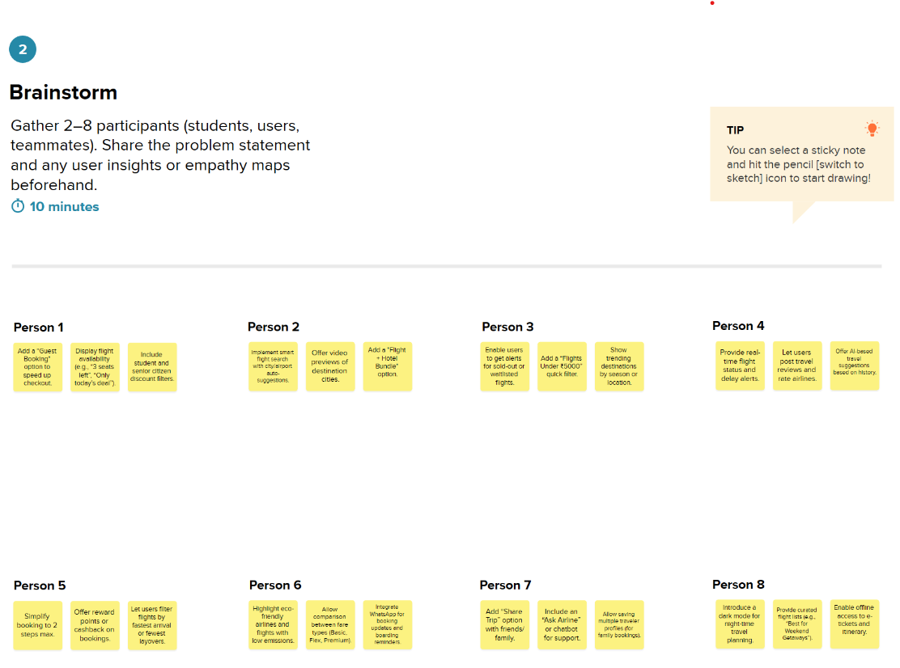

**Step-3: Idea Prioritization**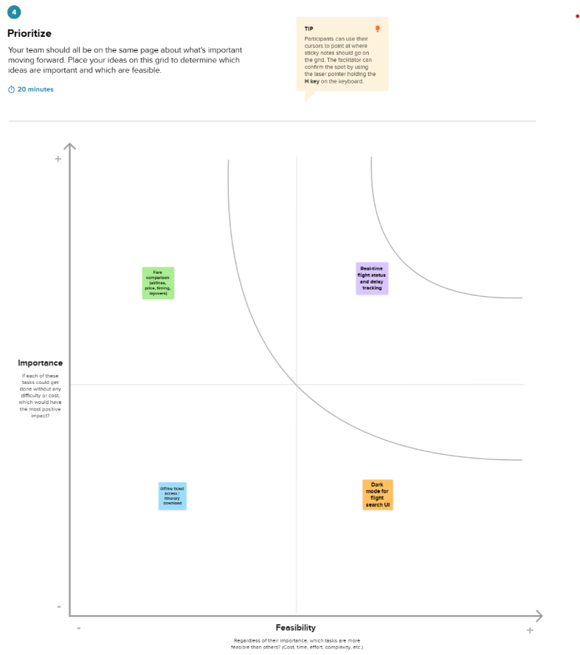

**Idea Overview**:  
The Flight Finder App is a web-based application developed using the MERN (MongoDB, Express.js, React.js, Node.js) stack. It allows users to search for available flights based on location, date, and other filters, view details, and make bookings.

**Prioritization Criteria**:

| **Idea/Feature** | **Impact** | **Feasibility** | **Priority** |
| --- | --- | --- | --- |
| Real-time flight search via API | High | Medium | High |
| User login and authentication | High | High | High |
| Admin panel for managing flights | Medium | Medium | Medium |
| Booking history and payment integration | High | Medium | High |
| Rating & feedback system | Medium | Low | Low |

**Reasoning**:  
The real-time flight search and user authentication were prioritized due to their direct impact on user experience and core functionality. While additional features like rating systems add value, they were placed in lower priority due to complexity and limited initial need.